Hypothesis Testing

Q1.A F&B manager wants to determine whether there is any significant difference in the diameter of the cutlet between two units. A randomly selected sample of cutlets was collected from both units and measured? Analyze the data and draw inferences at 5% significance level. Please state the assumptions and tests that you carried out to check validity of the assumptions.

# Step1 Business Problem

Two check whether the diameters of two units are similar or not?

# Step2 y and x

So here is y is continuous and x is discrete **Step3 Here we will use 2-sample t test Step4 Find normality of this data**

# Normality Test

Normality test for unit A

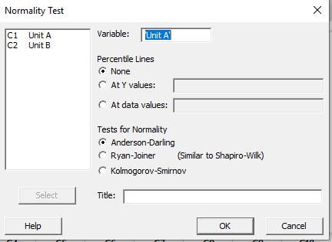

**null hypothesis(H0):Data are normal alternate hypothesis(Ha):data are not normal** if p-value is > 0.05 => Accept null hypothesis

if p-value is < 0.05 =>Reject null hypothesis

Alternate hypothesis is used when we take action or p-value is less than 0.05

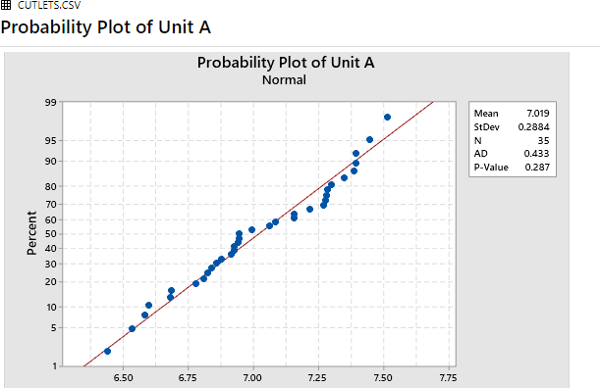

As p-value is 0.287 > 0.05 hence accept null hypothesis(H0)

# Normality test for unit B

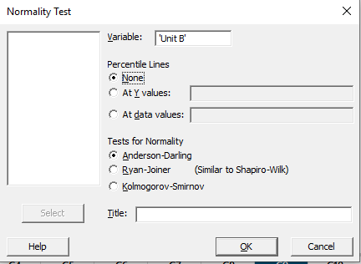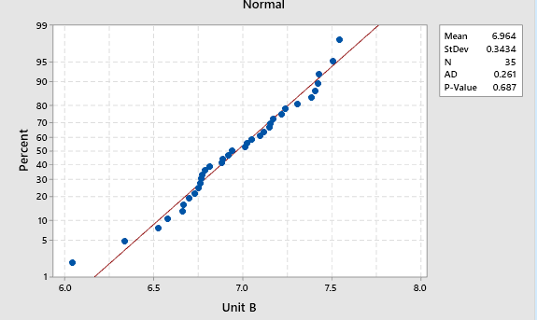

Here p-value is 0.687 > 0.05 => P high h0 fly

Hence accept null hypothesis(H0) which means data are normal we can go for further test which is variance test

# Variance Test

H0: variance of unitA = variance of unitB

Ha: variance of unitA NOT= variance of unitB

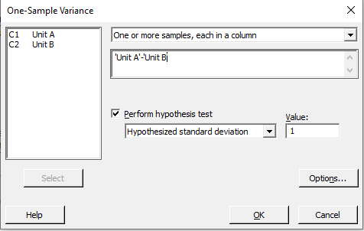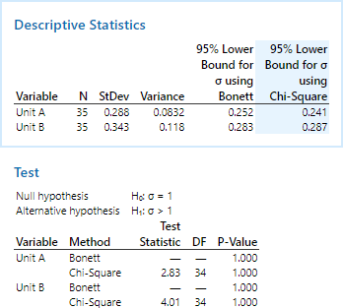

p-value is 1.00 > 0.05=>P high Ho fly => Accept Ho,Hence we prove variance of unitA = variance of unitB.

# 2 Sample t test for compare mean

H0:Average of unit A = Average of unit B

Ha: variance of unitA NOT = variance of unitB

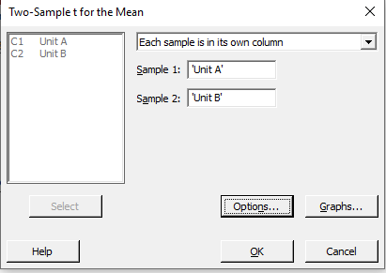

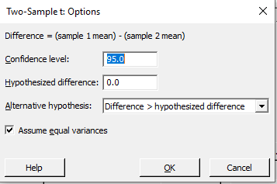

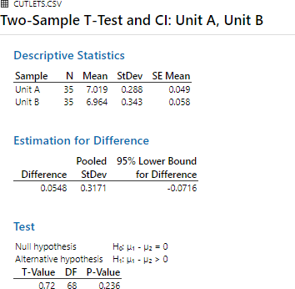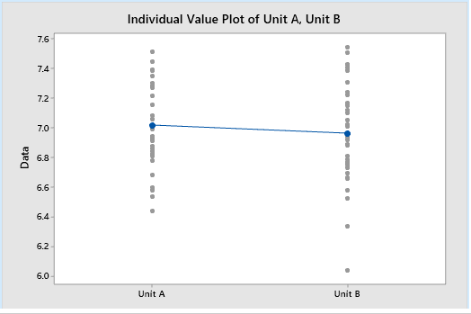

P-value is 0.236 > 0.05=>P high Ho fly => Accept Ho, hence Average of unit A = Average of unit B As per above results we can say that there is similarity between unitA and unitB i.e unitA = unitB

Q2.A hospital wants to determine whether there is any difference in the average Turn Around Time (TAT) of reports of the laboratories on their preferred list. They collected a random sample and recorded TAT for reports of 4 laboratories. TAT is defined as sample collected to report dispatch.

Analyze the data and determine whether there is any difference in average TAT among the different laboratories at 5% significance level.

# Step1 Business Problem

Two check whether there is any difference in average TAT

# Step2 y and x

So here is 4 labs are input TAT(Turn around time) is output x is more than 2 discrete and y is continous

# Step3 Here we will use ANOVA-One way

Find difference between 4 labrotaries with respect to time X -> 4 labratory

y -> TAT(Turn around time)

# Step4 Find normality of this data

**Normality Test**

Normality test for Laboratory 1

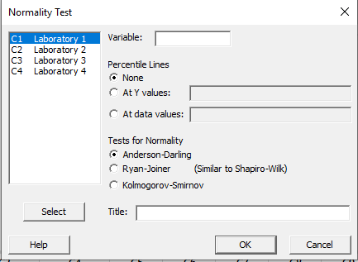

null hypothesis(h0):Data are normal alternate hypothesis(ha):data are not normal if p-value is > 0.05 => Accept null hypothesis if p-value is < 0.05 =>Reject null hypothesis

alternate hypothesis is used when we take action or p-value is less than 0.05

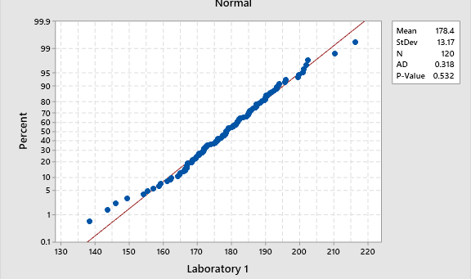

As p-value is 0.532 > 0.05 P high Ho fly => Accept Ho,hence accept null hypothesis(H0) means data are normal

Normality test for Laboratory 2

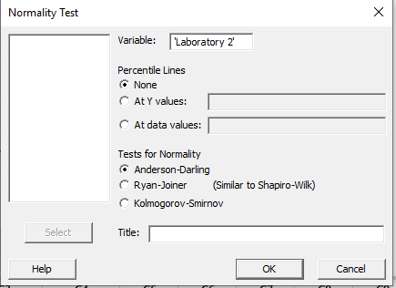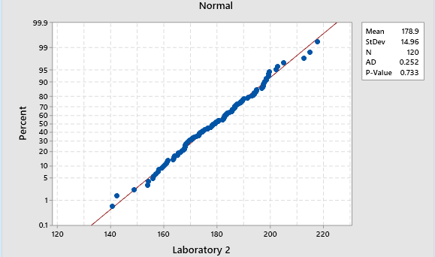

As p-value is 0.733 > 0.05 P high Ho fly => Accept Ho,hence accept null hypothesis(H0) means data are normal

1. Normality test for Laboratory 3

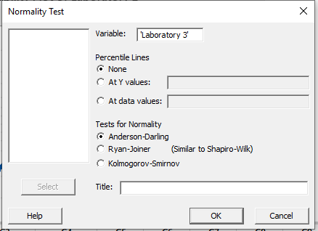

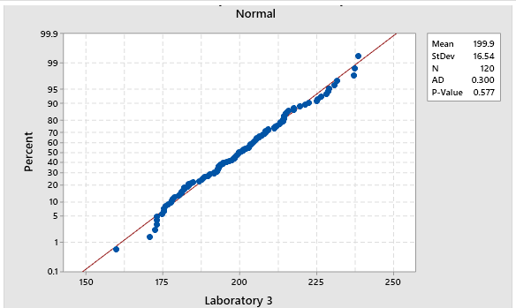

As p-value is 0.577 > 0.05 P high Ho fly => Accept Ho,hence accept null hypothesis(H0) means data are normal

1. Normality test for Laboratory 4

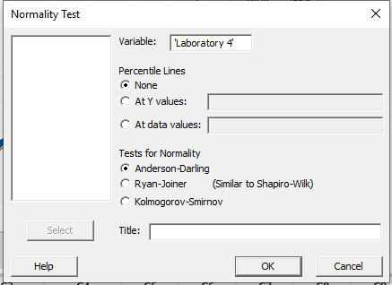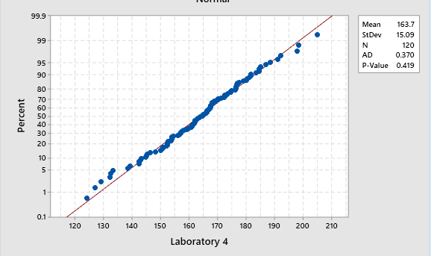

As p-value is 0.419 > 0.05 P high Ho fly => Accept Ho,hence accept null hypothesis(H0) means data are normal

# Variance Test

H0: All variance are equal

Ha: Atleast one variance is different

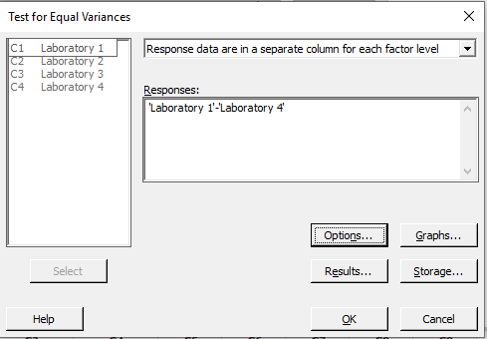

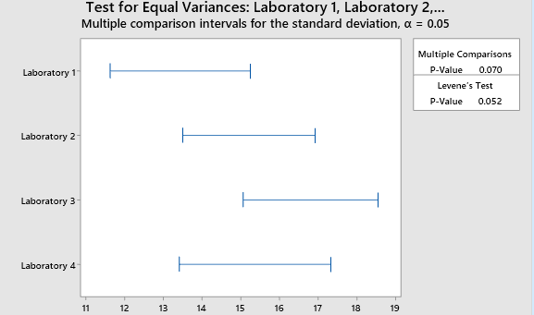

p-value is 0.070 > 0.05=>P high Ho fly => Accept Ho, hence we prove variance of all laboratory are same

# Anova Test-One way

H0:Average of all laboratory are same Ha:Average of atleast 1 laboratory are different

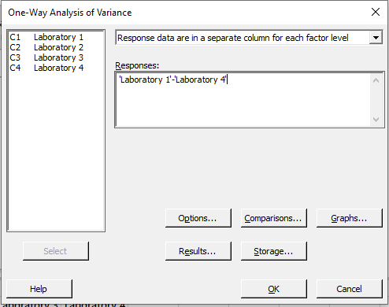

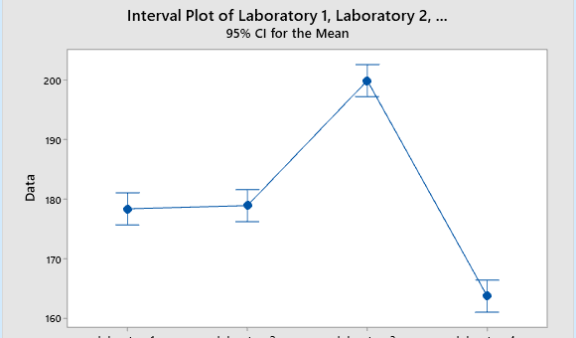

P-value is 0.00 < 0.05= Accept Ha, hence Average of atleast 1 laboratory are different

As per results we can say that these are not equal i.e Average of atleast 1 laboratory are different

Q3. Sales of products in four different regions is tabulated for males and females. Find if male- female buyer rations are similar across regions.

# Step1 Business Problem

Two find buyer ratios are similar across region or not

# Step2 y and x

x is more than 2 discrete and y is discrete **Step3 Here we will use Chi-square test Step4 Find normality of this data**

# Normality Test

1. Normality test for East

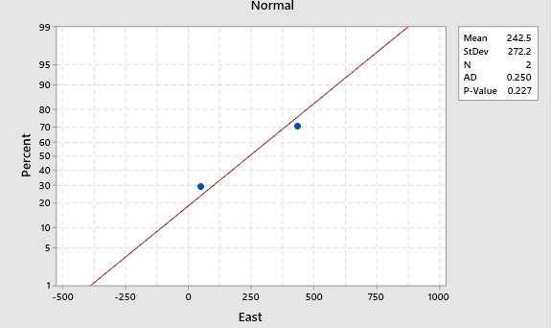

null hypothesis(h0):Data are normal alternate hypothesis(ha):data are not normal if p-value is > 0.05 => Accept null hypothesis if p-value is < 0.05 =>Reject null hypothesis

alternate hypothesis is used when we take action or p-value is less than 0.05

As p-value is 0.227 > 0.05 P high Ho fly => Accept Ho,hence accept null hypothesis(H0) means data are normal

1. Normality test for West

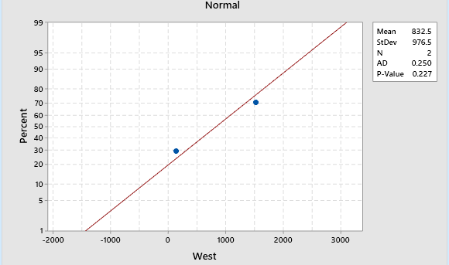

As p-value is 0.227 > 0.05 P high Ho fly => Accept Ho,hence accept null hypothesis(H0) means data are normal

1. Normality test for North

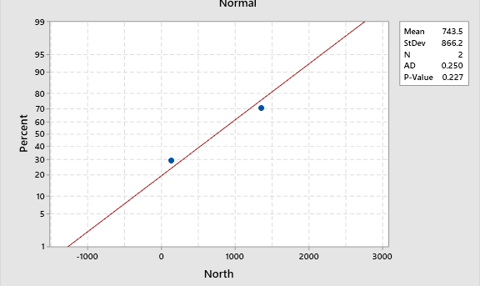

As p-value is 0.227 > 0.05 P high Ho fly => Accept Ho,hence accept null hypothesis(H0) means data are normal

1. Normality test for South

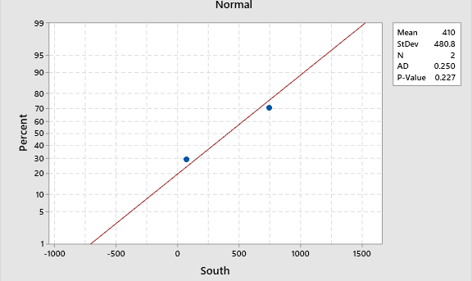

As p-value is 0.227 > 0.05 P high Ho fly => Accept Ho,hence accept null hypothesis(H0) means data are normal

# Chi-Square Test

H0:All averages are same Ha:atleast 1 are different

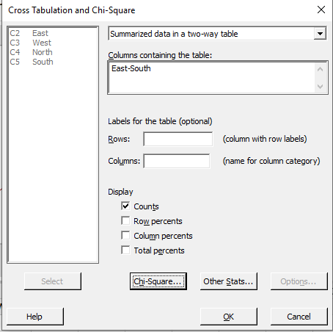

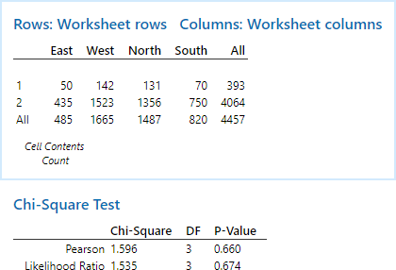

P-value is 0.674 > 0.05=>P high Ho fly => Accept Ho, hence Average are same

As per results we can say that there is proportion of male and female buying is similar

Q4.TeleCall uses 4 centers around the globe to process customer order forms. They audit a certain % of the customer order forms. Any error in order form renders it defective and has to be reworked before processing. The manager wants to check whether the defective % varies by centre. Please analyze the data at *5%* significance level and help the manager draw appropriate inferences

# Step1 Business Problem

To check whether the defective % varies by center or not

# Step2 y and x

x is more than 2 discrete and y is discrete **Step3 Here we will use Chi-square test Chi-Square Test**

H0:All are same Ha:atleast 1 are different

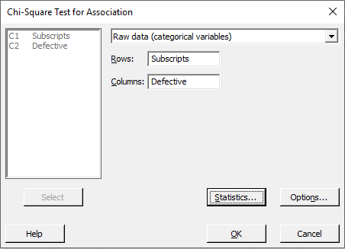

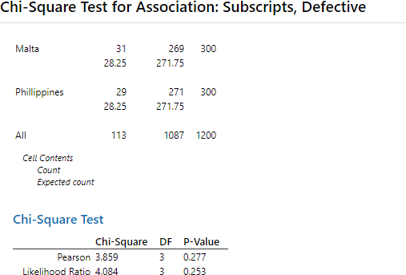

P-value is 0.227 > 0.05=>P high Ho fly => Accept Ho, hence Average are same As per results we can say that all the canters are equal.

Q5. Fantaloons Sales managers commented that *%* of males versus females walking in to the store differ based on day of the week. Analyze the data and determine whether there is evidence at *5 %* significance level to support this hypothesis.

# Step1 Business Problem

To find proportion male vs female differ from weekdays or weekends are equal or not

# Step2 y and x

x is discrete with 2 categories and y is discrete

# Step3 Here we will use 2-Proportion test

**2-Proprotion Test**

H0:Proportion of male vs female in weekdays = Proportion of male vs female in weekends Ha:Proportion of male vs female in weekdays NOT = Proportion of male vs female in weekends

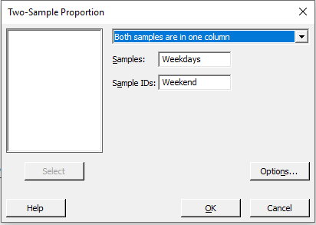

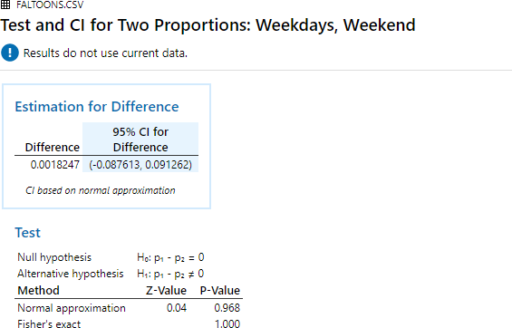

P-value is 0.968 > 0.05=>P high Ho fly => Accept Ho

Hence Proportion of male vs female in weekdays = Proportion of male vs female in weekends